Centroid colors:
import pandas as pd
import numpy as np
import matplotlib.pyplot as plt
import seaborn as sns
from sklearn.cluster import KMeans
from sklearn.preprocessing import StandardScaler
# Step 1: Generate synthetic dataset for Flipkart customers (Only 30 customers)
np.random.seed(42)
customer_count = 30
# Sample Indian customer names
customer_names = [
"Aarav", "Vihaan", "Ishaan", "Kabir", "Aryan", "Anaya", "Myra", "Aadhya", "Siya", "Riya",
"Neha", "Rohan", "Ritik", "Sanya", "Harsh", "Tushar", "Soham", "Ira", "Vivaan", "Kavya",
"Yash", "Kunal", "Raj", "Tanvi", "Krishna", "Aditya", "Meera", "Dev", "Anjali", "Sakshi"
]
# Generating random customer data
age = np.random.randint(18, 65, customer_count)
annual_income = np.random.randint(300000, 1500000, customer_count)
purchase_frequency = np.random.randint(1, 20, customer_count)
avg_order_value = np.random.randint(500, 10000, customer_count)
preferred_category = np.random.choice(['Electronics', 'Fashion', 'HomeGoods', 'Groceries', 'Books'], customer_count)
discount_sensitivity = np.random.uniform(0.1, 1.0, customer_count)
# Create DataFrame
data = pd.DataFrame({
'CustomerID': range(1, customer_count + 1),
'Name': customer_names,
'Age': age,
'AnnualIncome': annual_income,
'PurchaseFrequency': purchase_frequency,
'AvgOrderValue': avg_order_value,
'PreferredCategory': preferred_category,
'DiscountSensitivity': discount_sensitivity
})
# Step 2: Preprocess the data (only numeric features for clustering)
numeric_data = data[['Age', 'AnnualIncome', 'PurchaseFrequency', 'AvgOrderValue', 'DiscountSensitivity']]
# Standardize the data
scaler = StandardScaler()
scaled_data = scaler.fit_transform(numeric_data)
# Step 3: Elbow Method to determine the optimal number of clusters (K)
wcss = []
for i in range(1, 11):
kmeans = KMeans(n_clusters=i, random_state=42, n_init=10)
kmeans.fit(scaled_data)
wcss.append(kmeans.inertia_)
# Plot the Elbow Method
plt.figure(figsize=(8, 6))
plt.plot(range(1, 11), wcss, marker='o', linestyle='--', color='b')
plt.title('Elbow Method for Optimal K (30 Customers)')
plt.xlabel('Number of Clusters')
plt.ylabel('WCSS (Inertia)')
plt.grid(True)
plt.show()
# Step 4: Apply K-Means with the selected number of clusters (K=3)
optimal_k = 3 # Adjust based on the elbow plot
kmeans = KMeans(n_clusters=optimal_k, random_state=42, n_init=10)
data['Cluster'] = kmeans.fit_predict(scaled_data)
# Step 5: Show the first few rows of the dataset with cluster labels
print("\nClustered Data:")
print(data)
# Step 6: Cluster insights (mean of numeric features within each cluster)
numeric_columns = ['Age', 'AnnualIncome', 'PurchaseFrequency', 'AvgOrderValue', 'DiscountSensitivity']
cluster_insights = data.groupby('Cluster')[numeric_columns].mean()
# Display the cluster insights
print("\nCluster Insights (Average Features per Cluster):")
print(cluster_insights)
# Step 7: Visualizing the Clusters (Age vs Annual Income)
plt.figure(figsize=(10, 6))
# Define distinct colors for clusters
cluster_colors = {0: 'red', 1: 'green', 2: 'orange'} # Red, Green, Yellow/Orange
# Scatter plot of customers
for cluster, color in cluster_colors.items():
cluster_data = data[data['Cluster'] == cluster]
plt.scatter(cluster_data['Age'], cluster_data['AnnualIncome'], color=color, s=100, label=f'Cluster {cluster}')
# Mark centroids with the SAME colors as their respective clusters
centroids = scaler.inverse_transform(kmeans.cluster_centers_)
for i, centroid in enumerate(centroids):
plt.scatter(centroid[0], centroid[1], marker='X', s=300, color=cluster_colors[i], edgecolors='black', linewidth=2, label=f'Centroid {i}')
# Add customer names to points
for i in range(customer_count):
plt.text(data['Age'][i], data['AnnualIncome'][i], data['Name'][i], fontsize=9, ha='right')
plt.title('Customer Segments based on Age and Income')
plt.xlabel('Age')
plt.ylabel('Annual Income')
plt.legend()
plt.show()
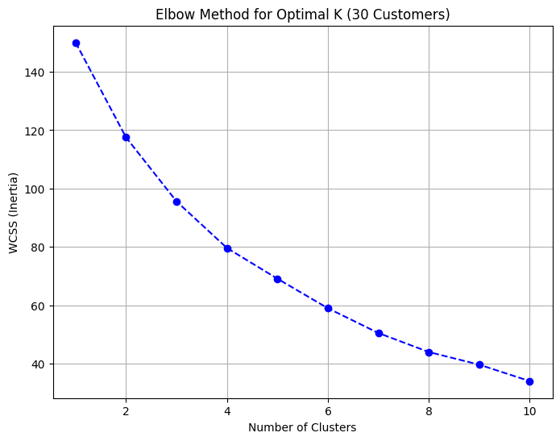
Clustered Data:
CustomerID Name Age AnnualIncome PurchaseFrequency AvgOrderValue \
0 1 Aarav 56 456730 14 8506
1 2 Vihaan 46 1498079 17 3068
2 3 Ishaan 32 954811 4 5963
3 4 Kabir 60 827035 18 2527
4 5 Aryan 25 948143 8 3195
5 6 Anaya 38 365725 4 5758
PreferredCategory DiscountSensitivity Cluster
0 Electronics 0.391911 1
1 Fashion 0.209879 2
2 Fashion 0.420668 1
3 Groceries 0.916146 0
Cluster Insights (Average Features per Cluster):
Age AnnualIncome PurchaseFrequency AvgOrderValue \
Cluster
0 36.285714 9.072700e+05 15.714286 5398.142857
1 44.125000 7.393701e+05 7.750000 7146.687500
2 40.142857 1.009533e+06 12.428571 2359.857143
DiscountSensitivity
Cluster
0 0.791965
1 0.387120
2 0.273192
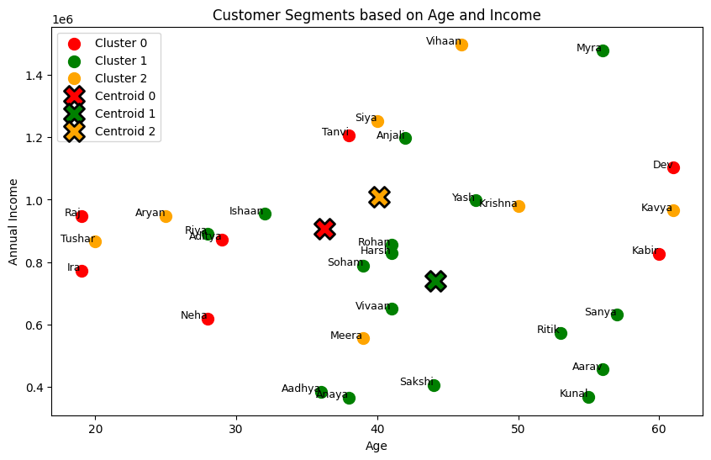
📊 Business Insights
1️⃣ Cluster 0 (🔴 Young Budget Shoppers) → Frequent buyers but low spending. Send them more discounts.
2️⃣ Cluster 1 (🟢 High-Value Buyers) → They buy less often but spend a lot. Recommend premium products.
3️⃣ Cluster 2 (🟠 Balanced Regular Customers) → Medium frequency & spending. Offer personalized deals.
Display Well -- Business Insights
import pandas as pd
import numpy as np
import matplotlib.pyplot as plt
import seaborn as sns
from sklearn.cluster import KMeans
from sklearn.preprocessing import StandardScaler
# Step 1: Generate synthetic dataset for Flipkart customers (Only 30 customers)
np.random.seed(42)
customer_count = 30
# Sample Indian customer names
customer_names = [
"Aarav", "Vihaan", "Ishaan", "Kabir", "Aryan", "Anaya", "Myra", "Aadhya", "Siya", "Riya",
"Neha", "Rohan", "Ritik", "Sanya", "Harsh", "Tushar", "Soham", "Ira", "Vivaan", "Kavya",
"Yash", "Kunal", "Raj", "Tanvi", "Krishna", "Aditya", "Meera", "Dev", "Anjali", "Sakshi"
]
# Generating random customer data
age = np.random.randint(18, 65, customer_count)
annual_income = np.random.randint(300000, 1500000, customer_count)
purchase_frequency = np.random.randint(1, 20, customer_count)
avg_order_value = np.random.randint(500, 10000, customer_count)
preferred_category = np.random.choice(['Electronics', 'Fashion', 'HomeGoods', 'Groceries', 'Books'], customer_count)
discount_sensitivity = np.random.uniform(0.1, 1.0, customer_count)
# Create DataFrame
data = pd.DataFrame({
'CustomerID': range(1, customer_count + 1),
'Name': customer_names,
'Age': age,
'AnnualIncome': annual_income,
'PurchaseFrequency': purchase_frequency,
'AvgOrderValue': avg_order_value,
'PreferredCategory': preferred_category,
'DiscountSensitivity': discount_sensitivity
})
# Step 2: Preprocess the data (only numeric features for clustering)
numeric_data = data[['Age', 'AnnualIncome', 'PurchaseFrequency', 'AvgOrderValue', 'DiscountSensitivity']]
# Standardize the data
scaler = StandardScaler()
scaled_data = scaler.fit_transform(numeric_data)
# Step 3: Elbow Method to determine the optimal number of clusters (K)
wcss = []
for i in range(1, 11):
kmeans = KMeans(n_clusters=i, random_state=42, n_init=10)
kmeans.fit(scaled_data)
wcss.append(kmeans.inertia_)
# Plot the Elbow Method
plt.figure(figsize=(8, 6))
plt.plot(range(1, 11), wcss, marker='o', linestyle='--', color='b')
plt.title('Elbow Method for Optimal K (30 Customers)')
plt.xlabel('Number of Clusters')
plt.ylabel('WCSS (Inertia)')
plt.grid(True)
plt.show()
# Step 4: Apply K-Means with the selected number of clusters (K=3)
optimal_k = 3 # Adjust based on the elbow plot
kmeans = KMeans(n_clusters=optimal_k, random_state=42, n_init=10)
data['Cluster'] = kmeans.fit_predict(scaled_data)
# Step 5: Show the first few rows of the dataset with cluster labels
print("\nClustered Data:")
print(data)
# Step 6: Cluster insights (mean of numeric features within each cluster)
numeric_columns = ['Age', 'AnnualIncome', 'PurchaseFrequency', 'AvgOrderValue', 'DiscountSensitivity']
cluster_insights = data.groupby('Cluster')[numeric_columns].mean()
# Display the cluster insights
print("\nCluster Insights (Average Features per Cluster):")
print(cluster_insights)
# Step 7: Define action points based on clusters
action_points = {
0: "💡 Offer premium membership & exclusive discounts!",
1: "📢 Recommend budget-friendly deals & coupons!",
2: "🎯 Promote high-value products with personalized ads!"
}
# Add action points based on cluster
data['ActionPoint'] = data['Cluster'].map(action_points)
# Step 8: Define cluster meanings based on characteristics
cluster_meanings = {
0: "Premium Customers - High income, frequent purchases",
1: "Budget-Conscious - Moderate income, low purchase frequency",
2: "High-Spenders - High order values, willing to spend on quality"
}
# Add cluster meanings based on cluster
data['ClusterMeaning'] = data['Cluster'].map(cluster_meanings)
# Step 9: Display the data with cluster, action point, and cluster meaning
print("\nCustomer Segmentation with Action Points and Cluster Meaning:")
print(data[['Name', 'Cluster', 'ClusterMeaning', 'ActionPoint']].to_string(index=False))
# Step 10: Visualizing the Clusters (Age vs Annual Income)
plt.figure(figsize=(10, 6))
# Define distinct colors for clusters
cluster_colors = {0: 'red', 1: 'green', 2: 'orange'} # Red, Green, Yellow/Orange
# Scatter plot of customers
for cluster, color in cluster_colors.items():
cluster_data = data[data['Cluster'] == cluster]
plt.scatter(cluster_data['Age'], cluster_data['AnnualIncome'], color=color, s=100, label=f'Cluster {cluster}')
# Mark centroids with the SAME colors as their respective clusters
centroids = scaler.inverse_transform(kmeans.cluster_centers_)
for i, centroid in enumerate(centroids):
plt.scatter(centroid[0], centroid[1], marker='X', s=300, color=cluster_colors[i], edgecolors='black', linewidth=2, label=f'Centroid {i}')
# Add customer names to points
for i in range(customer_count):
plt.text(data['Age'][i], data['AnnualIncome'][i], data['Name'][i], fontsize=9, ha='right')
plt.title('Customer Segments based on Age and Income')
plt.xlabel('Age')
plt.ylabel('Annual Income')
plt.legend()
plt.show()

Clustered Data:
CustomerID Name Age AnnualIncome PurchaseFrequency AvgOrderValue \
0 1 Aarav 56 456730 14 8506
1 2 Vihaan 46 1498079 17 3068
2 3 Ishaan 32 954811 4 5963
3 4 Kabir 60 827035 18 2527 8892
15 16 Tushar 20 865894 14
PreferredCategory DiscountSensitivity Cluster
0 Electronics 0.391911 1
1 Fashion 0.209879 2
2 Fashion 0.420668 1
3 Groceries 0.916146 0
4 Books 0.344919 2
5 HomeGoods 0.682921 1
Cluster Insights (Average Features per Cluster):
Age AnnualIncome PurchaseFrequency AvgOrderValue \
Cluster
0 36.285714 9.072700e+05 15.714286 5398.142857
1 44.125000 7.393701e+05 7.750000 7146.687500
2 40.142857 1.009533e+06 12.428571 2359.857143
DiscountSensitivity
Cluster
0 0.791965
1 0.387120
2 0.273192
Customer Segmentation with Action Points and Cluster Meaning:
Name Cluster ClusterMeaning ActionPoint
Aarav 1 Budget-Conscious - Moderate income, low purchase frequency 📢 Recommend budget-friendly deals & coupons!
Vihaan 2 High-Spenders - High order values, willing to spend on quality 🎯 Promote high-value products with personalized ads!
Ishaan 1 Budget-Conscious - Moderate income, low purchase frequency 📢 Recommend budget-friendly deals & coupons!
Kabir 0 Premium Customers - High income, frequent purchases 💡 Offer premium membership & exclusive discounts!
Aryan 2 High-Spenders - High order values, willing to spend on quality 🎯 Promote high-value products with personalized ads!
Anaya 1 Budget-Conscious - Moderate income, low purchase frequency 📢 Recommend budget-friendly deals & coupons!
Myra 1 Budget-Conscious - Moderate income, low purchase frequency 📢 Recommend budget-friendly deals & coupons!
Aadhya 1 Budget-Conscious - Moderate income, low purchase frequency 📢 Recommend budget-friendly deals & coupons!
Siya 2 High-Spenders - High order values, willing to spend on quality 🎯 Promote high-value products with personalized ads!
Riya 1 Budget-Conscious - Moderate income, low purchase frequency 📢 Recommend budget-friendly deals & coupons!

Expected Output:
1. Clustered Data:
After clustering, each customer will have a Cluster, Cluster Meaning, and Action Point associated with their data.
2. Cluster Insights:
Displays the mean values of the customer characteristics within each cluster.
3. Visualization:
Scatter plot of the clusters, showing how customers are distributed based on their Age and Annual Income, with centroid markers.

# THE END

